## INTRODUCTION

The Hospital Management System is a comprehensive project designed to streamline the operations of medical facilities efficiently. This system comprises three interconnected modules that collectively manage the interactions between administrators, doctors, and patients. Administrators have privileged access to register doctors into the system, ensuring a comprehensive database of healthcare professionals. Once doctors are onboarded, patients gain access to the platform, where they can browse through the available doctors and schedule appointments seamlessly.

Patients are empowered to register, log in, and schedule appointments based on their medical needs. Upon appointment confirmation, administrators oversee the allocation of patients to specific doctors, facilitating a tailored approach to healthcare delivery. The assigned doctors then receive detailed appointment information, allowing them to provide personalized treatment to each patient. Post-treatment, doctors update the appointment status, signaling completion of medical services.

Administrators maintain oversight throughout the process, accessing comprehensive dashboards that compile patient, doctor, and appointment details. This ensures efficient management of resources and enables administrators to make informed decisions to enhance the quality of care provided. In summary, the Hospital Management System optimizes the healthcare journey for all stakeholders, promoting seamless communication and efficient resource allocation within medical institutions.

## PROBLEM STATEMENT

The Hospital Management System (HMS) aims to address several key challenges faced by medical facilities in their day-to-day operations. Firstly, traditional paper-based systems for managing patient appointments, doctor schedules, and treatment records often lead to inefficiencies and errors. These outdated methods can result in scheduling conflicts, delays in patient care, and difficulty in accessing accurate medical histories, impacting the overall quality of healthcare services provided.

Secondly, the lack of centralized information systems within hospitals can hinder effective communication and collaboration between administrators, doctors, and patients. Without a unified platform to manage appointments, assign patients to doctors, and track treatment progress, medical staff may face difficulties in coordinating care, leading to potential gaps in patient follow-up and treatment continuity.

Furthermore, the increasing demand for healthcare services coupled with the complexity of managing a diverse range of medical professionals and patient populations necessitates the adoption of modern, technology-driven solutions. The absence of an integrated Hospital Management System can result in administrative burdens, resource wastage, and suboptimal patient outcomes, highlighting the urgent need for a comprehensive digital solution to streamline hospital operations and enhance the overall patient experience.

## PROJECT SCOPE

The scope of the Hospital Management System (HMS) project encompasses a wide array of functionalities aimed at enhancing the efficiency and effectiveness of medical facility operations. Firstly, the system will facilitate seamless registration and login processes for administrators, doctors, and patients, ensuring secure access to the platform. Administrators will have the capability to register doctors into the system, creating a centralized database of healthcare professionals, while patients will be able to browse and select from a list of available doctors for their medical needs.

Secondly, the HMS will enable patients to schedule appointments with their chosen doctors, providing a user-friendly interface for appointment management. Administrators will oversee the allocation of appointments to doctors based on patient needs, ensuring efficient utilization of medical resources. Once appointments are assigned, doctors will receive detailed information about their scheduled patients, enabling them to provide personalized care and treatment.

Lastly, the system will feature comprehensive dashboards for administrators to monitor and manage all aspects of hospital operations. This includes tracking patient appointments, managing doctor schedules, and accessing detailed reports on patient demographics and treatment outcomes. By providing administrators with real-time insights and analytics, the HMS will empower medical facilities to make data-driven decisions, optimize resource allocation, and ultimately improve the quality of patient care.

## AIMS & OBJECTIVES

The Hospital Management System (HMS) project is driven by several overarching aims and objectives, each tailored to optimize the delivery of healthcare services and enhance the overall operational efficiency of medical facilities.

### Specific goals are -

* The primary aim of the HMS is to streamline and optimize the delivery of healthcare services within medical institutions. By providing a comprehensive platform for managing patient appointments, doctor schedules, and treatment records, the HMS aims to minimize wait times, reduce administrative burdens, and enhance the overall quality of patient care.
* Another aim of the HMS is to promote transparent communication and collaboration among administrators, doctors, and patients. By centralizing patient information and appointment details, the HMS fosters a culture of transparency and accountability within medical facilities. This ensures that all stakeholders have access to accurate and up-to-date information, facilitating efficient decision-making processes and improving the overall patient experience.
* The HMS aims to empower stakeholders with timely and relevant insights to support informed decision-making. By consolidating patient, doctor, and appointment data and offering advanced reporting and analytics capabilities, the HMS enables administrators to make data-driven decisions that optimize resource allocation, improve operational workflows, and ultimately drive organizational success in delivering superior healthcare services.

## OVERALL DESCRIPTION

* The Hospital Management System (HMS) provides a comprehensive solution for managing the operations of medical facilities, facilitating seamless coordination between administrators, doctors, and patients. This system enables administrators to oversee various aspects of hospital management, including patient appointment scheduling, doctor allocation, and treatment monitoring, all within a centralized digital platform.

## PRODUCT PERSPECTIVE

* The HMS caters to administrators, doctors, and patients seeking an efficient and user- friendly online platform for managing healthcare services. By digitizing and centralizing patient records, appointment schedules, and treatment histories, the HMS eliminates the need for manual paperwork and enhances accessibility to vital healthcare information. Whether administrators are allocating appointments, doctors are treating patients, or patients are scheduling appointments, the HMS provides a unified perspective, promoting streamlined communication and collaboration across all stakeholders within the medical facility.

## USER CHARACTERISTICS

* User should be familiar with the terms like login, register etc.

## PRINCIPLE ACTORS

* Admin, Doctor, Patient.

## GENERAL CONSTRAINTS

* + A full internet connection is required.

## ASSUMPTIONS & DEPENDENCIES

* + Working of Hospital Management System website needs Internet Connection.

## BENEFITS OF HOSPITAL MANAGEMENT SYSTEM

* + This HMS solution is fully functional and flexible.
  + It is very easy to use.
  + This online system helps in back-office administration by streamlining and standardizing the procedures.
  + It saves a lot of time, because of remote access.
  + The application acts as an office that is open 24/7.
  + It increases the efficiency of the management at offering quality services to the customers.

## USERS AND CHARACTERISTICS

### Admin

* Admin can register and login.
* Admin can register doctor.
* Admin can view all doctor details.
* Admin can delete the doctors.
* Admin can view all the appointments from all the patients.
* Admin can view all patients
* Admin can delete the patient

### Doctor

* Doctor can login.
* Doctor can view the appointments assigned to him from Admin.
* Doctor can treat the patient and update the appointment status.
* Doctor can update the Employee Details and Employee Salary Details.
* Doctor can view the patient details.

### Patient

* Patient can register and login.
* Patient can view all the Doctors in system.
* Patient can take the appointments.
* Patient can view the appointment details.

## PROJECT FLOW

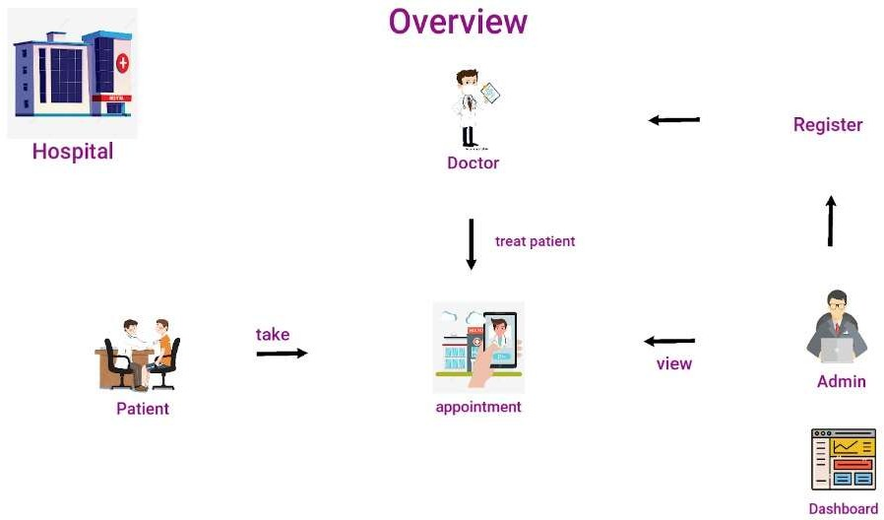

**MICROSERVICES STRUCTURE:**

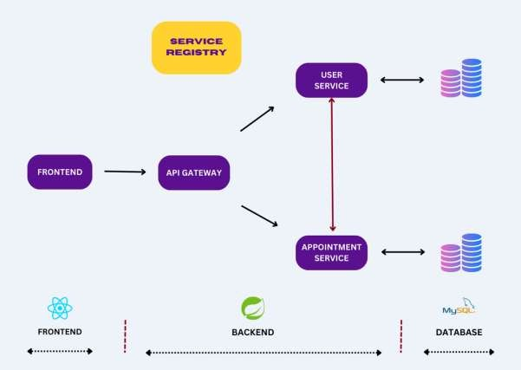

### API Gateway Service

An API Gateway is a component that acts as a single entry point for client applications to interact with various microservices within the system.

### Service Registry Service

A Service Registry is a component that facilitates service discovery and allows microservices to locate and communicate with each other dynamically.

### Hospital User Service

An Hospital User Microservice will handle all the User-related Operations.

### Hospital Appointment Service

An Hospital Appointment Microservice will handle all the Appointment-related Operations.

So the request will come to the API Gateway Service first during the request initialization from the front end. After this Microservices can communicate between them get the proper data that is to be sent to the front end.

## MODULE SPECIFICATION

**FUNCTIONAL REQUIREMENT**

This section provides requirement overview of the system. Various functional modules that can beimplemented by the system will be:

1. User Authentication Module:

# The registration and Login system has been added so that only authenticated users (Admin, Doctor, or Patient) can perform their functionalities.

1. Doctor Module:

# Register Doctor, View All Doctors, Delete Doctor.

1. Patient Module:

# Register Patient, View All Patients, Delete Patient.

1. Appointment Module:

# Take an Appointment, Assign an Appointment to a Doctor, Update the Appointment, Cancel an Appointment, and View All Appointments and status.

## NON FUNCTIONAL REQUIREMENTS

Following Non-Functional Requirements will be there in the insurance to the internet

* + Secure access to member’s confidential data.
  + 24X7 availability.
  + Better component design to get better performance at peak time.
  + Flexible service based architecture will be highly desirable for future extension Non-FunctionalRequirements define system properties and constraints.

### Various other Non-Functional Requirements are

* + Security
  + Reliability
  + Maintainability
  + Portability
  + Extensibility
  + Reusability
  + Compatibility
  + Resource Utilization

## REQUIREMENT ANALYSIS

Requirement Analysis means studying the existing system and collecting the details to find out what these requirements are. It is necessary to find out how the system works and where improvements are necessary.

### There are three activities involved in requirements analysis

* + Requirement Anticipation
  + Requirement Investigation
  + Requirement Specification

### Requirement Anticipation

* + Based on prior experience, which may have included specific issues or features and specifications for a new system, it forecasts the characteristics of the system.
  + It can result in an analysis of regions that a less skilled analyst might otherwise overlook. But requirement Anticipation can be flawed if quick cuts are used and bias is incorporatedthroughout the inquiry.

### Requirement Investigation

* + The system is being examined, and its attributes are being recorded for future research.
  + At the core of system analysis, fact-finding methods, prototyping, and computer-aided tools areused to record and describe system features.

### Requirement Specifications

* + It also comprises describing the features of the new system, stating the informationrequirements, and analyzing the data to determine the requirements.
  + It involves factual data analysis, critical requirement identification, and requirement fulfillmentstrategy selection.

### Information Gathering Techniques

The primary goal of fact-finding methodologies is to identify the information needs of an organization so that analysts can provide a precise SRS that users can understand.

The perfect SRS document should

* + Be thorough, clear, and jargon-free.
  + Cite the informational needs that are operational, tactical, and strategic.
  + Resolve any potential conflicts between users and analysts.
  + Take advantage of visual tools that make understanding and design simpler.

There is various information gathering techniques.

### Interviewing

A systems analyst uses interviews to get data from people or groups. As the effectiveness of an interview depends on the analyst's abilities as an interviewer, the analyst can be formal, legalistic,play politics, or informal.

It can be done in two ways:

* **Unstructured Interview -** To gather fundamental system knowledge, the system analystconducts a question and answer session.
* **Structured Interview -** It consists of predetermined questions to which the respondent mustprovide a close (objective) or open (descriptive) response.

### Advantage of Interviewing

* This approach is typically the most effective way to acquire qualitative data.
* It is helpful for those who struggle to express themselves clearly writing or who might nothave the time to finish the questionnaire.
* It is simple and quick to cross-check and confirms information.
* It is capable of handling difficult issues.
* By asking for opinions, it is simple to identify the main issue.

### Questionnaires

The analyst employs this technique to collect data from a sizable population of people on a variety of systemic concerns.

There are two types of questionnaires

* **Open-ended Questionnaires:** These contain open-ended, easily interpretable questions.They can go further into a problem and point in the right path for an answer.
* **Closed-ended Questionnaires:** These are questions that are employed after the systemsanalyst has effectively listed all alternate, mutually exclusive replies.

### Advantages of questionnaires

* It is excellent at gauging the interests, attitudes, sentiments, and beliefs of people who are notphysically present.
* Knowing the percentage of a certain group that supports or opposes a specific system featurecan be helpful in some circumstances.
* Prior to providing the system project with precise instructions, it is helpful to ascertain thegeneral consensus.
* It offers higher levels of anonymity and more trustworthy, sincere responses.

### Review of Documents, Forms, and Procedures

In order to get insight into a system that specifies the current system capabilities, its operations, orits activities, it can be helpful to review existing records, processes, and forms.

* It enables the user to learn a little bit about the business or its processes before imposing it onothers.
* As the procedure manuals and forms describe the structure and features of the current system,it aids in quickly recording current operations.
* It can offer a clear picture of the transactions handled within the company, identifying inputfor processing, and assessing performance.
* A system analyst may find it useful to comprehend the processes that the system must support.

### Observations

This technique involves noticing and observing people, events, and objects in order to gain information. The analyst pays a visit to the company to study the operation of the current system and comprehend its needs.

### Advantages

* In situations when the validity of the data collected is questioned or where the complexity ofsome system components makes it difficult for end users to understand something clearly, thisdirect approach to gathering information might be helpful.
* It generates data that is more accurate and dependable.
* It generates all the outdated and insufficient documentation aspects.

## HARDWARE AND SOFTWARE REQUIREMENTS SPECIFICATION

### Hardware Requirements

**Processor**: Any Processor above 1 GH & above.

**RAM**: Minimum 4GB.

**Hard Disk**: Minimum 500 GB.

**Processor**: Any processor above 1 GH & above.

### Software Requirements

**Front End**: React JS/JavaScript/Bootstrap.

**Backend (Business Logic)**: Java, Spring Boot Microservices.

**Database**: MySQL 8.0.

**Server**: Embedded Tomcat Server.

**Editor**: Spring Tool Suite (STS), VS Code.

**Operating System**: Windows.

## ABOUT THE TECHNOLOGIES USED

With the advent of the latest technology if we do not update our system then our business result in losses gradually with time.

Here, Java Spring Boot is used for logic and view purposes. For designing

React JS/ HTML/CSS/Bootstrap/JavaScript is used. For Database MySQL 8.0 version is used.

### Spring Tool Suite (STS)

Spring Tool Suite (STS) is an integrated development environment (IDE) tailored for developers working with Spring Framework applications. Offering a seamless experience, STS combines essential tools for coding, debugging, and deploying Spring-based applications. With features like code completion, built-in support for Maven and Gradle, and comprehensive debugging capabilities, developers can efficiently build robust Spring applications. Its integration with other Spring projects like Spring Boot enhances productivity by simplifying project setup and configuration. STS provides a rich set of tools that streamline the development process, making it a preferred choice for Spring developers seeking a powerful and intuitive IDE.

### Java Spring Boot

Java Spring Boot revolutionizes the way developers create Java-based web applications by simplifying the process of building, configuring, and deploying them. Spring Boot eliminates the need for extensive XML configuration and boilerplate code by leveraging convention over configuration principles. With its embedded HTTP server and auto-configuration capabilities, developers can quickly create standalone, production-ready Spring applications with minimal setup. Additionally, Spring Boot's extensive ecosystem of starter dependencies and built-in support for common tasks like security, database access, and RESTful APIs further accelerates development. Its emphasis on opinionated defaults and streamlined development workflows has made Spring Boot a cornerstone in modern Java application development, empowering developers to focus more on business logic and less on infrastructure concerns.

### React JS

React JS, developed by Facebook, has emerged as a dominant player in the realm of front- end web development, renowned for its declarative and component-based architecture. With React, developers can efficiently build dynamic user interfaces by composing reusable UI components. Its virtual DOM implementation ensures optimal performance by selectively updating only the necessary parts of the DOM. React's unidirectional data flow and state management solutions like Redux facilitate predictable and scalable application development. Moreover, its vibrant ecosystem, including tools like React Router for navigation and Redux Saga for managing asynchronous actions, empowers developers to create immersive and feature-rich web applications. React's popularity continues to soar, fueled by its simplicity, performance, and robust community support, making it a go-to choice for modern web development projects.

## HTML

HTML is an acronym that stands for Hyper Text Mark-up Language. Hyper Text simply

means “Text within text”. A text as a link within it is a hypertext. A Mark-Up language is a computer language that is used to apply layout and formatting conventions to a text document. Mark-up language makes the text more interactive and dynamic. It can turn text into images, tables, links, etc. With the help of styling, it looks in a nice format. An HTML document is made of many HTML tags and each HTML tag contains different content.

## CSS

CSS stands for Cascading Style Sheets. It is a style sheet language that is used to describe the look and formatting of a document written in a markup language. It provides an additional feature to HTML. It is generally used to change the style of the user interface. It can also be used with any kind of XML documents.

### Bootstrap

It includes HTML and CSS-based design templates for buttons, tables, images carousels, and many others. It facilitates the creation of a responsive design. Bootstrap contains a lot of reusable components and custom jQuery plugins. Bootstrap components are customizable and we can customize bootstrap’s components, less variable and jQuery plugins to get our own style.

## USE CASE DIAGRAM

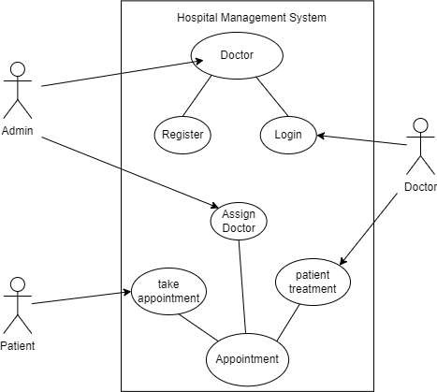

**ENTITY RELATIONSHIP DIAGRAM (ER Diagram)**

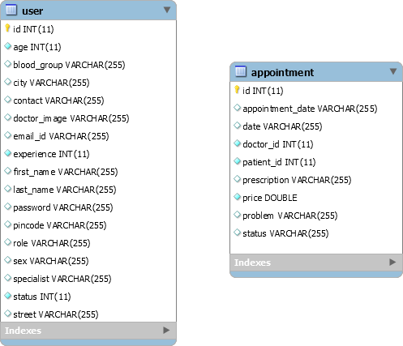

**DATA BASE STRUCTURE**

**APPOINTMENT TABLE**

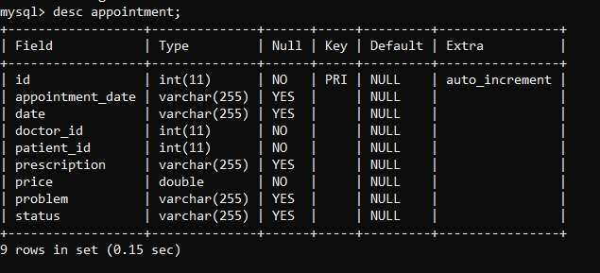

**USER TABLE**

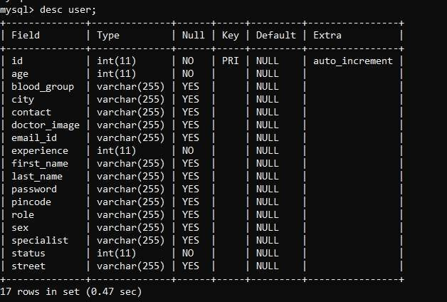

**TESTING**

Testing is a process, which reveals errors in the program. It is the major quality measure employed during software development. During software development, during testing the program is executed with a set of test cases and the output of the program for the cases is evaluated to determine if the program is performing as it is expected to perform.

Testing is a process to show the correctness of the program. Testing is needed to show completeness, it improves the quality of the software and to provide the maintenance aid. Some testing standards are therefore necessary reduce the testing costs and operation time. Testing software extends throughout the coding phase and it represents the ultimate review of configuration, design and coding. Based on the way the software reacts to these testing. We can decide whether the configuration that has been built is study or not. All components of an application are tested, as the failure to do so many results in a series of bugs after the software is put to use.

### Black Box Testing

Black box testing also called behavioral testing, focuses on the functional requirements of software. This testing approach enables the software engineer to derive the input conditions that will fully exercise all requirements for a program. Black box testing attempts to find the errors like

* Incorrect or missing functions.
* Interface errors.
* Errors in data structures or external database access.
* Behavior or performance errors.
* Initialization and termination errors.
* In black box testing software is exercised over a full age of inputs and outputsare observed for correctness.

### White Box Testing

White box testing is also called Glass box testing is a test case design control, structure of the procedural design to derive test cases using white box testing method. The software engineer can derive the test cases that guarantee that all independent paths within the module have been exercised at least once. Exercise all logic decisions on their true or false sides. Execute all loops at their boundaries and within their operational bounds. Exercise internal data structure to ensure their validity.

### Types of Testing

* Unit Testing
* Integration Testing
* System Testing

### Unit Testing

Unit testing is a process verification effort on the smallest unit of software i.e the module. Using the detailed design and the process specification testing is done to uncover errors within the boundary of the module. All modules must be successful in the unit test before the start of the integration testing begins. In this project each service can be thought of a module.

Giving different sets of inputs has tested each module. When developing the module as well as finishing the development so that each module works without any error. The inputs are validated when accepting from the user. In this application developer tests the programs up as system. Software units in a system are the modules and routines that are assembled and ignored to form a specific function. Unit testing is first done on modules, independent of one another to locate errors. This enables to detect errors. Through this error resulting from interaction between modules initially avoided.

### Integration Testing

After the unit testing we have to perform integration testing. The goal here is to see if modules can be integrated properly, the emphasis being on testing the design and hence the emphasison testing module interactions.

In this project integrating all the modules forms the main system. When integrating all the modules we have checked whether the integration effects working of any of the services by giving different combination of inputs with which the two services are perfectly before integration.

### System Testing

Here the entire project system is tested. The reference document for this process is the requirements document, and the goal as to see if software meets its requirements.

|  |  |  |  |
| --- | --- | --- | --- |
| **TEST CASE NUMB ER** | **TESTING SCENARIO** | **TESTING SCENARI O** | **RESULT** |
| **Login Testing** | | | |
| TC – 1 | Clicking submitentering wrong  Username | Alert "Invalid User" | Pass |
| TC – 2 | Clicking submitentering wrong  password | Alert "Invalid User" | Pass |
| TC – 3 | Clicking submit  entering wrong username and  password | Alert "Invalid User" | Pass |
| TC – 4 | Clicking submit without entering name | Alert "Please fill name" | Pass |
| TC – 5 | Clicking submit  without entering phone no | Alert "Please fill phone no" | Pass |

## TEST CASES

Test cases are good in revealing the presence of faults. Successful in implementation of test casesimplies that there are no error in program. Test cases should be minimum as they are expensive in cases of money and efforts. Primary Objectives of test cases are to ensure that if there is an error or fault in program it is exercise by the test cases. An ideal test cases set is one thatsucceeds only if there are no error in the program. One possible ideal set of set case is one that includes all possible input to the program and is called exhaustive testing. A test case is good if itdetect in undiscovered error in program.

**LOGIN**

|  |  |  |  |  |
| --- | --- | --- | --- | --- |
| **SL.NO** | **Input Values** | **Expected Output** | **Actual Output** | **Result** |
| 1 | Login in without username and password | Error message anddirected to same  page | Error messageand  directed to same page | No Error |
| 2 | If user is new. Click on  register button . | Will go to new form | Will go to new form | No Error |
| 3 | Incorrect User id  orpassword | Error message anddirected to same  page | Error messageand  directed to same page | No Error |

**ADMIN**

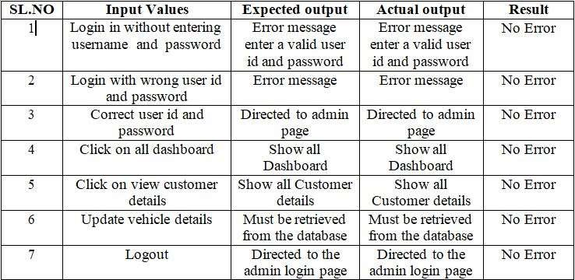

**VALIDATIONS**

|  |  |  |
| --- | --- | --- |
| **Attributes** | **On module/page** | **Validation** |
| Name, phone no, Email-id, address | Admin Registration | Should be not null |
| Password, Retype password | Admin Registration | Should match the  password |
| Username, password | Login | Should match with the system database |
| Employee Salary details | Add Salary | Proper Data required |
| Employee Salary details | Update Salary | Proper Data required |

## PROJECT SCREENSHOTS

**CONCLUSIONS**

In conclusion, the Hospital Management System (HMS) stands as a pivotal solution in modernizing and optimizing healthcare delivery within medical institutions. By digitizing and centralizing patient records, appointment scheduling, and treatment management, the HMS streamlines operations, reduces administrative burdens, and enhances the overall quality of patient care. Through its user-friendly interface and comprehensive features, the HMS fosters transparent communication and collaboration among administrators, doctors, and patients, ultimately contributing to improved decision-making processes and organizational success in delivering superior healthcare services.

As medical facilities continue to evolve in response to growing demands and technological advancements, the HMS remains a vital tool in driving efficiency, transparency, and accountability within healthcare organizations. By empowering stakeholders with real-time insights and data-driven analytics, the HMS enables informed decision-making, optimized resource allocation, and continuous improvement in patient outcomes. In essence, the HMS represents not only a technological advancement but also a commitment to excellence in healthcare management, ensuring that medical facilities can effectively meet the evolving needs of patients and healthcare professionals alike.

## FUTURE ENHANCEMENT

Future enhancements for the Hospital Management System (HMS) could focus on further optimizing efficiency, enhancing user experience, and expanding functionality to meet evolving healthcare needs. One potential enhancement could involve the integration of telemedicine capabilities, allowing patients to consult with doctors remotely, thereby increasing accessibility to healthcare services and reducing the need for in-person visits.

Additionally, incorporating predictive analytics and machine learning algorithms into the HMS could enable proactive identification of patient health trends and risk factors, facilitating early intervention and personalized treatment plans. This enhancement would not only improve patient outcomes but also enhance the predictive capabilities of the system, aiding administrators in resource allocation and strategic decision-making.

Furthermore, the HMS could benefit from interoperability features that enable seamless integration with external healthcare systems and devices, such as electronic health records (EHR) systems and IoT-enabled medical devices. This interoperability would promote data exchange and continuity of care across different healthcare settings, ultimately improving care coordination and patient satisfaction.

Moreover, incorporating features for patient engagement and education within the HMS could empower patients to take a more active role in managing their health. Interactive tools, educational resources, and personalized health tracking functionalities could help patients make informed decisions about their healthcare, leading to better treatment adherence and outcomes.

Overall, future enhancements to the HMS should aim to leverage emerging technologies and address evolving healthcare needs, ultimately enhancing the system's effectiveness in improving patient care and organizational efficiency.

## BIBLIOGRAPHY

1. [www.google.com](http://www.google.com/)
2. [www.youtube.com](http://www.youtube.com/)
3. [www.javatpoint.cm](http://www.javatpoint.cm/)
4. [www.tutorialspoint.com](http://www.tutorialspoint.com/)
5. [www.w3schools.com](http://www.w3schools.com/)
6. [www.codejava.net](http://www.codejava.net/)
7. [www.javatutor.com](http://www.javatutor.com/)
8. [www.simplecodestuffs.com](http://www.simplecodestuffs.com/)